International Day of Plant Health Video Contest
Plant Health TV - Promoting the importance of Plant Health research
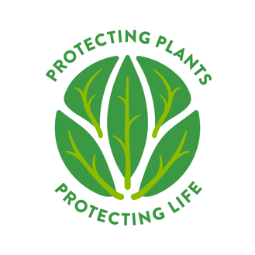

ANNEX I

Expression of Interest (Embedded link)

First name
Family name
E-mail address
Phone number
Organization
Country
Title of the video
Short summary of the video
Date
Signature

I declare that I am an early career researcher and agree to my personal data (email, address, name) being stored and used for the purposes under this call and to receive and send information by the contest organizers.

With reference to the video I declare that I am the exclusive author of the video, and that the same is an original work, of which I guarantee to hold full ownership and availability (not violating any provision of law in force, such as, by way of example and not limited to, the provisions on the protection of personal data, image, personality and reputation, copyright and all industrial and intellectual property rights, including those of third parties).
I expressly authorising the organizers to store, publish and/or disseminate in any form the work submitted, for the purposes of this notice.

To be returned to the Secretariat videocontest@iamb.it

In English

