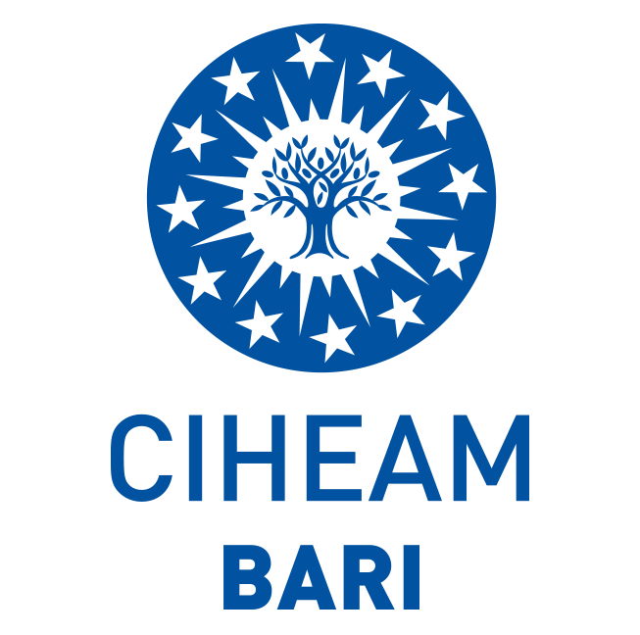

CIHEAM BARI APPLICATION FORM
FOR TRAINING COURSE:
“Digital skills enhancement in the green & blue economy” (Project: Food4Health)

I the undersigned:

Name and Surname ____________________________

Born in _________, on ________________

Gender
  - Male
  - Female
Resident in/at ___________ (full address), ________ (country)

Identified by the valid ID document N° ___________________

Phone _________________ Mobile _________________

Hereby apply for participation in the training course on “Digital skills enhancement in the green & blue economy” in accordance with the public Call published on the CIHEAM Bari website (www.iamb.it);

Hereby declare under my own responsibility to have no Criminal Records, nor pending prosecutions under the national law of my country of residence;

Hereby declare:

- To be a national resident or domiciled in
  - Puglia (IT)
  - Molise (IT)
  - Albania
  - Montenegro

- To have a good knowledge of the English language
- To be a graduate (bachelor degree) or nearly graduating student (enrolled in the final year of a bachelor degree).
Furthermore, I hereby declare:

I earned the following degree (please indicate the highest graduate degree you have obtained):

- High school degree (please specify)
  - _______________________________________________
- Bachelor degree (please specify)
  - _______________________________________________

- Master degree (please specify)
  - _______________________________________________

- Post-graduate qualifications and other professional qualifications (please specify):

- PhD on
- __________________
- __________________
- __________________
- University master courses (I or II level) on
- ___________________
- ___________________
- ___________________
- Advanced vocational training and higher education:
  - ___________________
  - ___________________
  - ___________________

The following documents are attached:

- Curriculum vitae in English (Europass format, in pdf format, duly signed). Candidates are demanded to clearly insert place and date of birth as well as actual residence in the CV;
- Motivation Letter in English (1000 characters Max). A short description of the motivations for applying, also with regard to interests, skills and digital/IT experience;
- Identity document (copy of valid passport in PDF format);
- Personal data treatment statement duly signed for approval.

Date, signature

_______________

